**Team Data Science Process (TDSP)**

The “**Team Data Science Process (TDSP)**” is Microsoft’s agile, iterative data science methodology to deliver predictive analytics solutions and intelligent applications efficiently. **TDSP** lifecycle is composed of five major stages that are executed iteratively and these stages include:

* Business Understanding
* Data Acquisition and Understanding
* Modeling
* Deployment
* Customer Acceptance

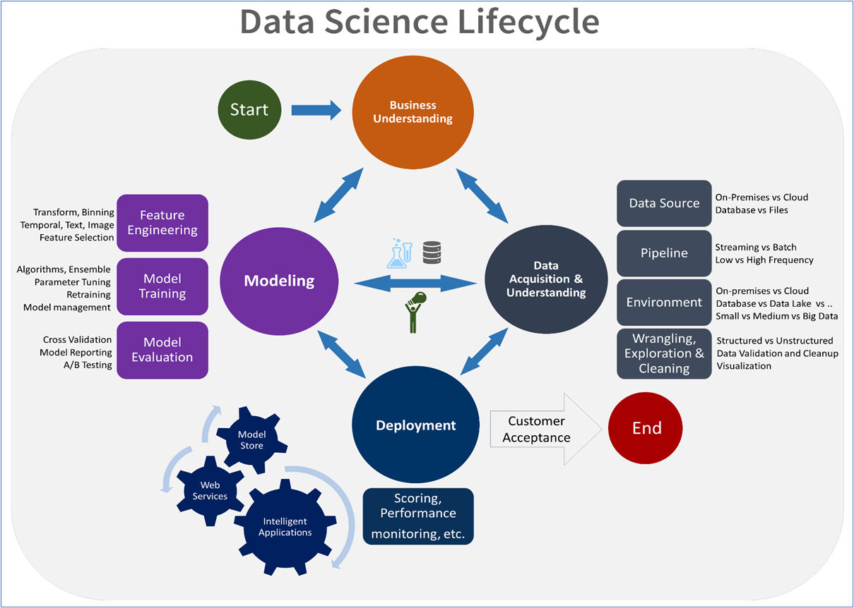

<https://docs.microsoft.com/en-us/azure/machine-learning/team-data-science-process/overview>